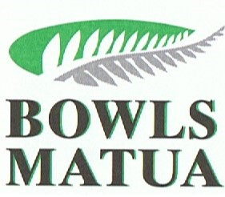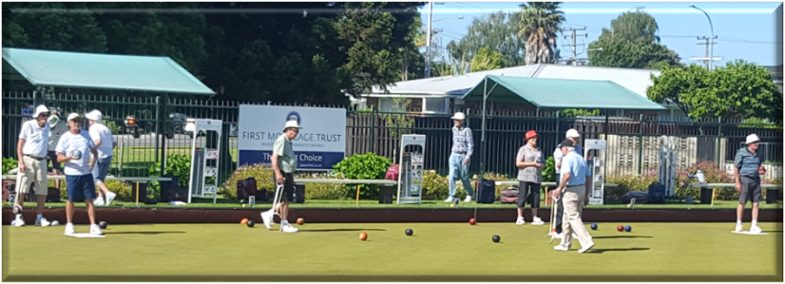
Ibbotsen Memorial Rosebowl
Winners Lyn Donovan, Marj Flowerday, Lynne Vincent
Runner-up Pat Gillon, Barry Sheary, Pat Walton

Mixed Handicap Singles
Winner Lynda Boschat Runner-up Ray Nicholas

Mixed Box Drawn Pairs
Winners Bill de Graaf, Ron Dockary Runner-up Ian Boyd, Marj Flowerday

Betty Upton Box Drawn Mixed Kiwi Pairs 2x4x2
Winners John George, Raelyn Hayes Runner-up Julia Matthewson, Grant Edgar

Miri McMillan Cup (Mixed)
Winners Ray Hogan, Ray Nicholas, Max Peters
Runner-up Ron Edge, Dennis Gillard, Gloria MacGibbon

Merlot Cup (Most Improved 1st or 2nd Year Player
Winner Ave Andrews

McKain Cup – Mixed Box Drawn Variety Triples
Winners Jean Sheary, Ian Boyd, Malcolm Gurden
Runner-up Ross Dean, Marj Flowerday, Denis Toovey
